* They cannot go on any electronics but they can play board games
* They pray
* They prepared for Shabbat on Friday. It is on Saturday.
* They celebrate God making the world
* They light candles

Shabbat

|  |  |
| --- | --- |
| **Key Vocabulary** | |
| Jew | People whose religion is Judaism |
| Abraham | Was the first Jew |
| Moses | He was a Jew who led slaves out of Egypt |
| Pharaoh | A King or Queen of Egypt |
| desert | The driest places on earth |
| Shabbat | Judaism's day of rest on the seventh day of the week |

Abraham

* Trusted God
* His wife dreamed of having a baby
* God told Abraham to count the stars but he couldn’t because there were too many. He then told God that he would have the same amount of children as stars.
* His dream came true! He was 99 when he had a baby boy called Isaac

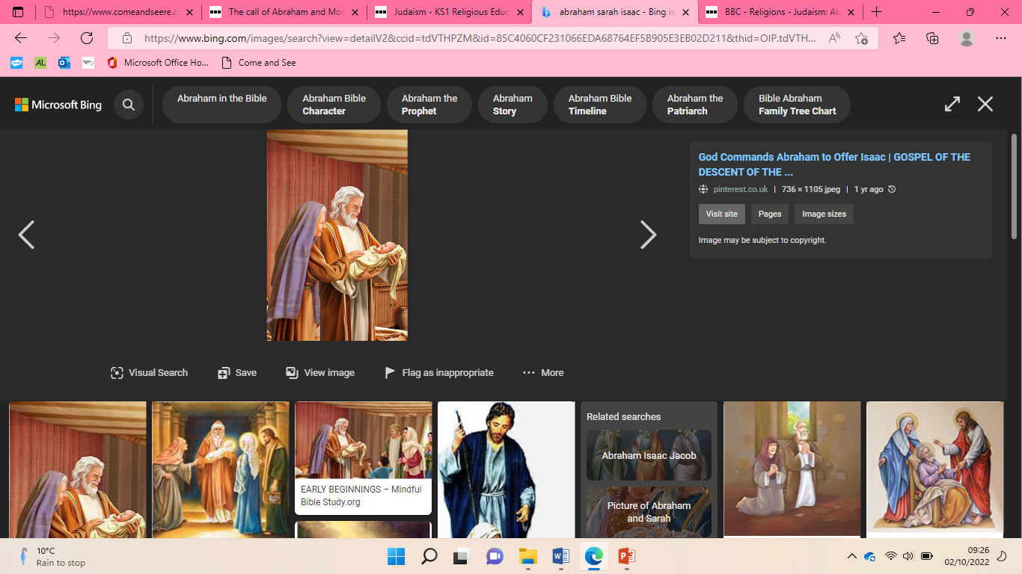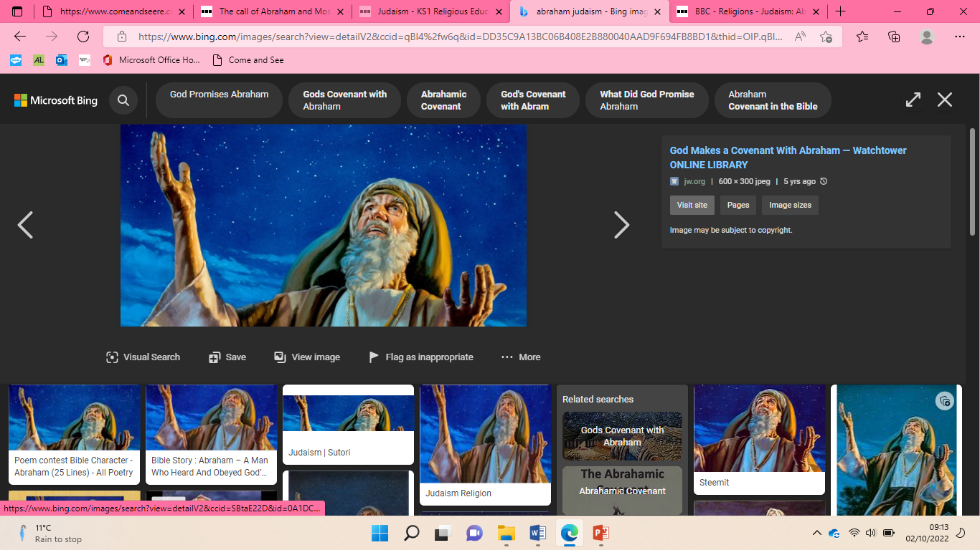



* God’s people were made to be slaves by Pharaoh
* God wanted to save his people so he sent Moses
* God made the river blood and sent different insects and frogs down.
* Pharaoh kept saying ‘If you stop I will let them go.’ But then he changed his mind each time.
* God said he would kill every first born son. God’s people put a cross from lamb’s blood above their doors.
* He saved the people of Egypt

|  |
| --- |
| Moses |

Judaism