Newsletter 17th April 2020
Dear Parents
It was confirmed yesterday that the UK will remain in a state of lockdown for at least three weeks.
Every household in the country has been asked to contribute to this by staying home, to protect the NHS and to save lives. Even if you don’t yet know someone affected by the virus then we have all seen and heard the tragedies across the country. This is so far from any experiences that most of us have experienced in our lifetimes. It is a great responsibility and it does seem that across the country most are staying in their own homes and keeping to the social distancing rules. I hope that you can feel proud that you are keeping to this despite the challenges it may be causing.
Here in the South West we are not seeing the level of illness that is being experienced in other parts of the country. My own family and relatives live in the North East and The North West where levels of illness are very high. One of my brothers has been seriously ill, a nephew of mine, who is a teacher in the early phase of his career, is still very ill. Sadly we lost a family friend who was over 70 but without the virus we would have expected him to live for many years; he was a very active person. For me this is a very real threat to lives and I now know that staying home if we can is a very important part in making a huge difference.
Some of St Mary’s parents are keyworkers, some contributing directly to the front line of medical care. People across the UK are finally realising the importance of other keyworkers in making our country function at all times and particularly at the moment. It is reassuring and just that care workers are now being recognised for the amazing work they have always undertaken and continue to do at this time.
Kindness Matters
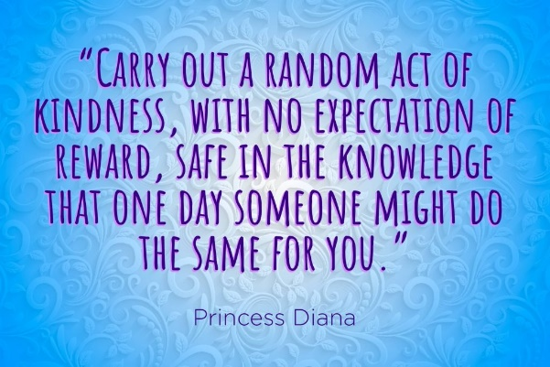

All of our families are working to adjust to lockdown. For some it appears it has so far been relatively straight forward and others are facing a range of challenges. It is important that you know we are here. We can be emailed or telephoned and we will do what we can. We have access to a wide range of agencies and we can signpost and support. It is important if you face a real challenge that you do not think you are the only person in this situation. We teach your children to recognise when they need support and to know that it is important to tell others. We find out who their ‘safe ‘ people are; those who they can tell the best and the worst of their thoughts, successes, worries or challenge. If you need a safe person we can be there for you and we know that many of you are there for others. It is something very important that you can show your children at this time. It will be an experience that they can learn from forever.
Learning Partnership
All of our families have taken on the important role of supporting our children’s learning at this time. This is now the 4th week of the lockdown and you have just completed a week and a half of home schooling. I respect and support the choice some families have made to maintain learning through the Easter holiday whilst others relaxed or stopped learning. It is important that you feel you can create a balance that works for your family.
St Mary’s website class pages and resources for national school closure
Teachers have created new learning for Monday 20th April on our school website. Follow the new link; ‘Class pages and resources for national school closure’. As well as class pages there are general resources and links to help learning. Robin Class continue to prioritise Tapestry.
Reading Matters: Read, read and read some more
Now that we know we will have at least two weeks after next week we will continue to consider what tasks and resources may help to support learning. As I have said before, keeping your child reading and taking part in reading tasks; listening to quality stories, talking about what they are reading, asking and answering questions about what they are reading are important tasks. Please support this by using resources directed to your children. Again I stress the merits of Bug Club. Teachers can see the reading tasks your child is doing. Children who have strong reading through KS1 and into KS2 have a significant learning advantage for all of their education.
If you want to give your children the opportunity to listen to stories :
https://www.booktrust.org.uk/books-and-reading/have-some-fun/storybooks-and-games/
Times tables are a very important and practical focus for this time. Times tables should be learned in order, out of order and applied to division facts.
We have directed your children to a wide range of learning; much of it is practical. This week for example. kestrel Class are learning the time. If they can already tell the time then they are asked to apply this to some time challenges.
Learning happen in many different ways. In school we do practical learning all of the time. Much of our maths learning is done by giving children time to talk to each other so that they are developing maths vocabulary. We are very active at many times in the day.
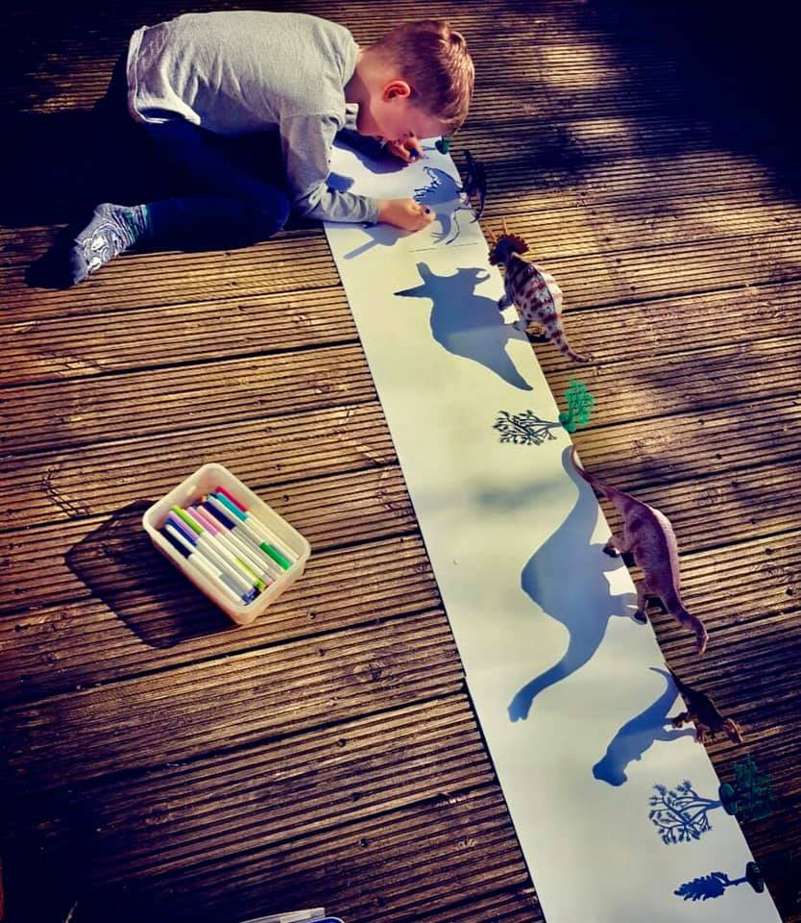
Some parents are finding their children are enjoying learning about space, others are involving their children in cooking and I was pleased to see one of our pupils enjoying daily fresh air by practising cycling skills.
If you have any worries or concerns about any aspect of your child’s learning then let us know. It is good to get the feedback from parents as that helps us to know what we need to offer.
St Mary’s Catholic Primary School Facebook Group
We have set up a St Mary’s Facebook group that allows teachers to post information and resources. Once you have joined the group you can view all of the feeds from across the school or you can go to the unit section to find units related to your child’s class. The unit ‘whole school ‘ is relevant to the whole school.
Please note that Robin Class information will continue to be posted via Tapestry as this is an established system which the parents and staff are used to using. Robin Class parents can access whole school information via the ‘whole school’ unit.
When looking at your child’s class information you are able to add comments or questions relating to that post.
This is a private group and you can join by going to this link:
https://www.facebook.com/groups/StMarysAx/ on a laptop, computer or web browser on a mobile device. And request to join.
Alternatively, you can email to admin@stmarysaxminster.devon.sch.uk your email address linked to your Facebook account and we can provide access.
We hope that you will find this helpful during the current lockdown.
Please also note that questions not related to the posts should always be directed to school admin.

Behind the scenes
Teachers and support staff are working on a wide range of tasks to support the current situation as well as tasks to ensure that we continue to move forward. We have all been kept very busy both in term time and through the Easter holidays due to this extraordinary time. We are looking at changing residential dates and organising Leavers sweatshirts (details to follow), planning learning , researching new learning options, lots and lots of new admin and school has been open for some children and families so we have been working to ensure that all are safe and adhere to social distancing. The school has had a deep clean in preparation for the return of all pupils. This week we also will be finding out and welcoming our new children for September. Over the next week we will be communicating directly with relevant parents about many of these and more.
St Mary’s is a GOOD School
You will know that in two years we have come a long way by building a strong sense of team and constantly looking for ways to build children’s skills and confidence. Much of this was achieved by the systems we had in place. This will not be lost during this phase.
Free School Meals – who are the Government seeking to support ?
There has been a lot of information in the press about free school meals and what the Government are doing to support this. Talk of supermarket vouchers has also been widely discussed. This is not for those families who qualify for infant free school meals or what is called universal free school meals. All children in Reception, Year 1 and Year 2 are automatically in this group.
The families that the government have been seeking to support are those families who apply via the local authority based on their individual situation. Schools know who these families are and schools have to first work with their local food supplier to seek a solution. If their local food supplier cannot offer a solution then the school can access the national voucher scheme for the families who qualify. If you have any questions about St Mary’s response to this requirement then in the first instance be reassured that we have a provision in place. If you have any other questions then please do email school.
Rainbows now and ahead
Despite the challenges it is always heart warming to notice the good. Captain Tom has captured everyone’s hearts this week. If somehow you’ve missed this story of quiet heroics then do take a few minutes to read about him :
https://www.bbc.co.uk/news/uk-england-beds-bucks-herts-52303859
Stay safe
With very best wishes Mrs Mannix on behalf of all at St Mary’s

