This Harvest Festival let’s help others as much as we can.

*If you would like to send a message of encouragement to The Foodbank please return this with your child on Wednesday. They may like to colour the leaf.*

*A harvest gift from*

*…………………..*

*With best wishes*

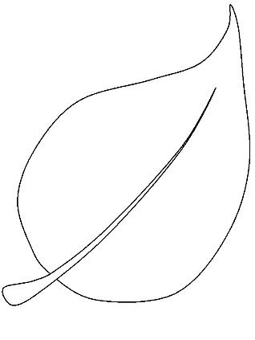

St Mary’s Harvest Giving

Our Harvest Celebration is on Wednesday 10th October at 10.10am.

All are welcome to join us.

Small things with Great Love

This week we have been stopping to think what we can be grateful for.

We recognise that we all have challenges and many of us know what we don’t have that might make our lives better. We are good at noticing these things but this week we are looking at what we have. Homes and people who care and will listen to us; water and shelter. Things many people do not have.

This year for Harvest we collecting for The Axminster Foodbank, which is a local community project helping people in need.

The Foodbank welcome all dry and tinned foods that can be stored and then shared when needed.

Examples include :

Tinned soup, beans, spaghetti, rice pudding, vegetables, fruit, meat and fish.

Tea , coffee and Longlife milk

Dog and cat food

Food bank Volunteers are very grateful for your support.

Anything you can give is appreciated.

Thank you for your continued support.