Health Awareness Week 14th to 18th October 2019

Many schools, including St Mary’s have achieved the Healthy Schools Award.
For today’s children, educating, supporting and developing healthy attitudes is so much more than encouraging them to choose fruit over chocolate or vegetables over chips.
Being healthy is a state of mind as well as activity and action. It is an individual activity as well as a group, team, family and community venture. 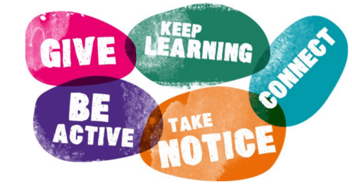
During our health awareness week we will encourage children to have a go at new activities, take up activities that they already love. Spend time with their friends, as well as be introduced to adults like Axminster Community police officer, Hayley Widger and talking about health food and drink options.
All children will work with Matt from Just 4 Funk. Matt is a male street dancer, who began life as a gymnast and then combined free running ( or parkour ) with street dancing to develop his skills and strength. Matt now works across Devon engaging children and young people in this fun and energetic dance form.
To contrast this all pupils will work with local yoga, ballet and tap and jazz expert, Niclaire, who will combine her many years of dance experience to teach Thai Yoga.
Dance provides ways to work independently and in groups to learn skills, improve fitness and have fun. We hope to be able to offer more opportunities for dance in the next year.
One of the long standing community police officers in Axminster, Hayley Widger, will work with the children to share her own reasons for working in the police force and what she and others in Devon police do to keep us safe. Being safe gives us a strong sense of well being. When our safety is challenged it is difficult for us to function. Hayley is keen to reassure children that despite all of the headlines on the national and local news Axminster is a safe place. She will also talk to children about what they can do to keep themselves safe; reinforcing our work in school about each individuals right to be safe. At St Mary’s we constantly stress the importance of being able to say STOP to anyone who is doing or saying things that make us feel unhappy or unsfe. We have also worked to reinforce the right to TELL and to make sure that evry child does have at least one person in school they can tell if they need support.
Young people have always been influenced by each other and felt the pressure to be like others. We are working to empower every child at St Mary’s to be able to manage that challenge. We are working with them to develop skills that will be relevant through al stages of their lives.
An important message that child will see, hear and recognise at St Mary’s is that each child is unique. Each child brings different skills, attitudes and experiences and at St Mary’s we will work to celebrate that uniqueness and every child to know how they shine. It is also true that every child should be helped to work with the areas that challenge them; in ways that make them feel safe and do not undermine their sense of self. We are all works of art. We are all developing and learning.
During this week we will be reminding each of them of this and we hope that during parents consultations you hear the ways that your child is developing as an individual. We are constantly grateful to parents for their on going support. If you are unable to attend parents consultations this week please do arrange with your child’s class teacher to see your child’s work. Knowing that you have seen their work and progress will encourage them further.
We also have additional art classes this week lead by Mrs Hogarth, our art teacher, who works directly with our older pupils and at the same time advises teachers on ways to make the most of art lessons.
In addition our safeguarding governor Hilary Sharp, has been cooking with children this half term, making cakes with vegetables in them; a healthier take on a fruit muffin. This week she will be combining art with cooking and inviting parents and parish members into school to draw, eat and chat.
We will also focus on animals. The local vets practice will talk to our younger children about ways to care for animals and we will have Murphy, a registered therapy dog in school.
We will also have our Harvest Festival Celebration this week. Last year we had a theme of doing small things with great love, which ran through the year. We saw each time how a small act repeated by many made a huge difference and Harvest Giving is a great example of that. In our harvest celebration we will be signing and sharing learning ; a great way to develop a sense of well being.
All of these themes run throughout our year. Wellbeing doesn’t happen in a day or week but we thought that this would be a positive way to bring the themes together.
We have been working with all children to encourage them to notice what they have. What really makes them happy.
Our oldest children have been looking again at the Unicef Rights and Responsibilities Children’s Charter and have been considering what do we need and what do we want. A very grown up reflection yet children know that what they really need is a safe home, people to listen to celebrate with and to share their worries and food, opportunities to learn and to play. They have been learning that not every child has these.
Owl Class have taken it upon themselves to collect items as a class for the shoe box appeal. They are aiming to make up 6 boxes by working together. We will let you know how that goes.
Kestrel Class are also planning an activity for Children in Need. They will be encouraging children to bring in toys and books for a sale to raise funds for this worthwhile charity.
We are very grateful to our pastoral care support worker, Lindsey Clist, for putting together this programme. Lindsey is available by appointment on Thursdays and Fridays to chat about any aspects of child development, relationship and parenting. She has a wide range of expertise as well as a calm and positive manner. She will work directly with parents as well as being in a position to coordinate and signpost to many services. Lindsey is often in the playground before school on Thursday and Friday. You are always welcome to speak to her.
A reminder that after half term we have a week of dance workshops with the London specialist dance company Spring Dance Company. The shared theme will be the story, The Selfish Giant. It tells about someone who seems to have everything but only finds happiness when they are helped to share what they have.
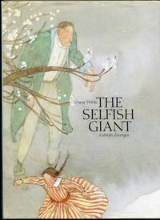

We wish you a very peaceful and happy half term.
We look forward to continuing learning on Tuesday 28th October.
Mrs Mannix
On behalf of the St Mary’s Staff Team

