St Mary’s Catholic Primary School Axminster
Living, loving and learning with God

Family updates
Thursday 7th May 2020
Now and Next
We had thought that we would be given an update on Thursday 7th May but like you we are now being told that we will hear more when Boris Johnson speaks to the nation on Sunday 10th May.
Education leaders have been told that schools will have notice to prepare for any changes so we expect that next week we will not be returning to school.
Teachers are currently preparing resources for your children which will be posted on the school website or on Tapestry for Robin Class.
The following week beginning 18th May teachers will be asking children to review their learning before we reach May Half term ( from Friday 22nd May to Tuesday 2nd June ).
It is assumed that clear guidance going forward will be made available to us all and we will better know what is happening.
Whatever the news please be reassured that we will keep you updated and will work hard to support any next steps.
Bug Club
Congratulations and keep on going with the hard work and focus on Bug Club. This reading resource setting has now been changed so that when you have read all the allocated books and answered all the questions, the site will auto-progress you to the next level. Keep going everyone. If you haven’t caught the Bug Club reading bug yet it’s not too late.
Bank Holidays and School Holiday
During national school closure school remains open for bank holidays and school holidays for key workers and vulnerable children. These families are communicated separately and know how to inform school of pupil attendance at school. If you have any questions or queries about this provision in the first instance please email admin@stmarusaxminster.devon.sch.uk

Friday 8th May – Bank Holiday and VE Day Celebrations
VE day the 75th anniversary of the end of World War II . Our older children who have been studying World War II will enjoy knowing about this. All of our children have seen photos and had this time shared with them each year when we celebrate Remembrance Day. This year it seems especially important to share this as the children can gain confidence from seeing how the Uk came through over 5 years of war.
This weekend across the UK our country had been planning to celebrate this in many ways with many public events that obviously can’t go ahead. There are lots of ideas of ways to mark this date whilst we are in lockdown.
https://www.britishlegion.org.uk/get-involved/remembrance/remembrance-events/ve-day-75
Tuesday 12th May Florence Nightingale 200 years
Again next week marks 200 years since the birth of Florence Nightingale who is the inspiration for the Governments Nightingale Hospitals set up to support the NHS meet the medical needs resulting from this virus.
Florence Nightingale is an important figure for her work to progress medical practice as well as for her own actions to ensure that nursing was viewed a profession.
https://www.rcn.org.uk/magazines/bulletin/2020/march/celebrating-florence-nightingale
The Great Realisation
If you haven’t yet seen this reflection you may find it interesting. It is a family reflecting back from the future on what the people of the world learned about this time.. it is fiction but many have found it interesting.
https://www.youtube.com/watch?v=bea4jCAkXsI

Wellbeing of all
None of us have faced any like this before and in light of the high levels of change and adjustment we are having to make it can present new challenges.
All will be aware of the on going focus on you and your well being alongside that of your children.
If you are feeling overwhelmed this might be a new feeling for you. Or you might feel that at the moment you can’t talk to those who you might normally rely on for support.
There are many ways that we have been advised to shift those feelings. Look for something that works for you. If it doesn’t shift then take a different action.
At St Mary’s we teach your children that asking for help when we need it is a strength. That is because it is a strength.
Each one of us is important and special. Please know that you are important. If you need support do seek support. We are all also asked to be extra aware that those around us may need support. Please be watchful of friends and neighbours where you can. The smallest acts of kindness will be appreciated.
Below are two key websites with links to further advice and support.
https://www.nspcc.org.uk/keeping-children-safe/coronavirus-advice-suppport-children-families-parents/
https://youngminds.org.uk/blog/tips-for-parents-in-a-difficult-living-situation-during-lockdown/
Local Authority Message to all parents in Devon
One of the concerns raised through the media about the additional risks that being at home creates for children and adults is the concern for domestic abuse. I’m quite sure that you will have seen the broadcasts on television aimed at those who are victims of domestic abuse. Please be aware that if you or any one you know are currently suffering in this way support and help for you is available.
The local authority have asked every school to be a place of safety.
We have asked St Mary’s to open the school up as a place of safety for victims to make a phone call for help.
St Mary’s Response We are keen to support in any way that we can but are also sensitive to the fact that we cannot guarantee that school will be accessible every school day because that depends on places being needed by families. So of course if school is open then if you need to do this please come to school and ask for Mrs Mannix. Let them know that you ‘need a place of safety to make a phone call’ and they will take you to the Heads office where you can contact the appropriate help. ``
Alternatively be aware of the following :
The Silent Solution system, which prompts 999 callers to press 55 on mobile devices to signify they are unable to speak.
You can call 111 and if an emergency 999.
Text or phone Mrs Mannix via the mobile set up for emergencies on 07493 825328

Ways to make links
Teachers who have been telephoning parents over the last two weeks have said that you are all doing an amazing job to respond to this situation. We have seen lots of the children’s work that you have emailed to us or posted on the Facebook Group.
Making links seems to be a really good way to lift our spirits. Please do continue to send us your children’s work and any good news that you would like us to share and we will continue to do whatever we can to make links with you.
In our wider community the older members are missing others too. They have asked if you would consider organising a rainbow painting, a letter, a drawing with a message and sending them in to school so that we can pass them on to those who may have no one in their household and no way to leave their homes.

Owl Class were excited to hear that Miss Hutton’s little girl has finally arrived safe and well. Meet Frankie Katherine.
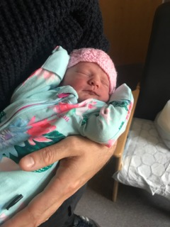

Wildlife in lockdown
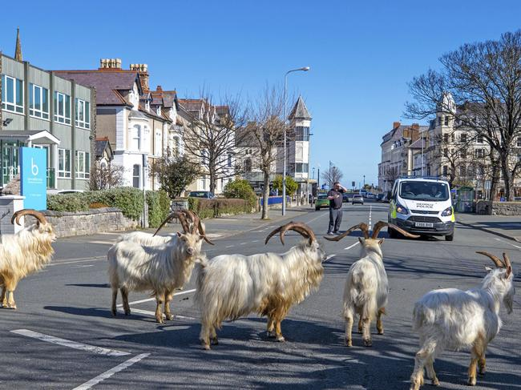

A real rainbow over my street last Thursday when we clapped for the NHS.

Sending very best wishes to all
From Mrs Mannix on behalf of all at St Mary’s.

