|  |  |
| --- | --- |
| **Key Vocabulary** | |
| Paint Program | An online system used to draw. |
| Tool | A device used to help with tasks. |
| Paintbrush | A brush used to apply paint. |
| Erase | To remove something. |
| Fill | Put objects or liquids into containers. |
| Undo | To cancel what has just happened. |
| Piet Mondrian | A Dutch painter and art theoretician who is regarded as one of the greatest artists of the 20th century. |
| Primary Colours | Red, blue and yellow- these cannot be created by mixing other colours |
| Shape Tools | The item that you use to help you draw a shape. |
| Line Tool | The item that you use to help you draw a line. |
| Henri Matisse | A French visual artist, known for both his use of colour and his fluid and original draughtsmanship. |
| Wassily Kandinsky | A Russian abstract painter and art theorist. |
| Feelings | Emotions. |
| Colour | Red, blue, green etc. |
| Brush Style | The way you use your paint brush. |
| Georges Seurat | A French post-Impressionist artist who devised pointillism. |
| Pointillism | Lots of tiny dots together to make up a picture. |
| Brush Size | How large or small your brush is. |
| Pictures | A painting or drawing. |
| Painting | The action of using paint as a picture or decoration. |
| Computers | An electronic device used to store and process data. |
| Like | To enjoy or approve of something. |
| Prefer | To like something more than something else. |
| Dislike | To not enjoy something. |

To change the paint tool

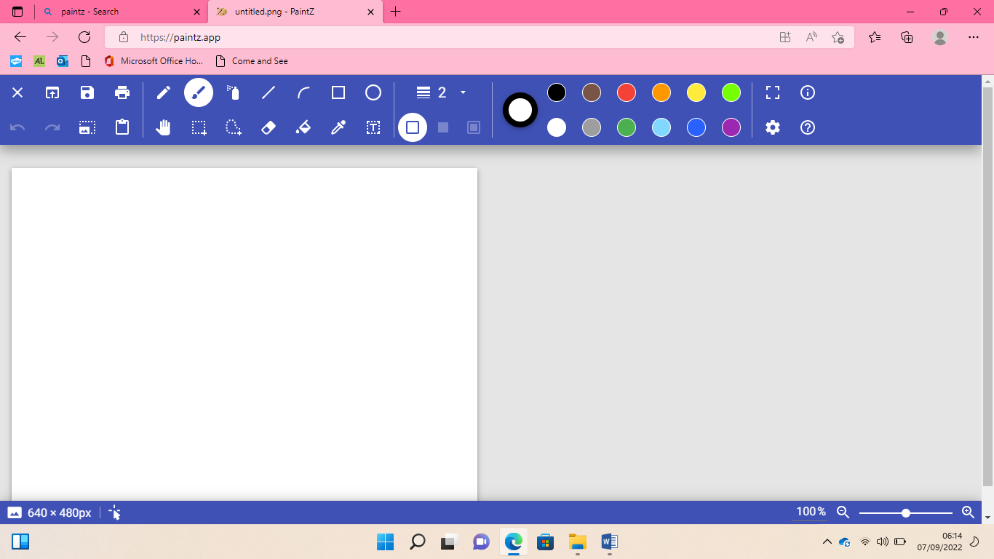

Wassily Kandinsky

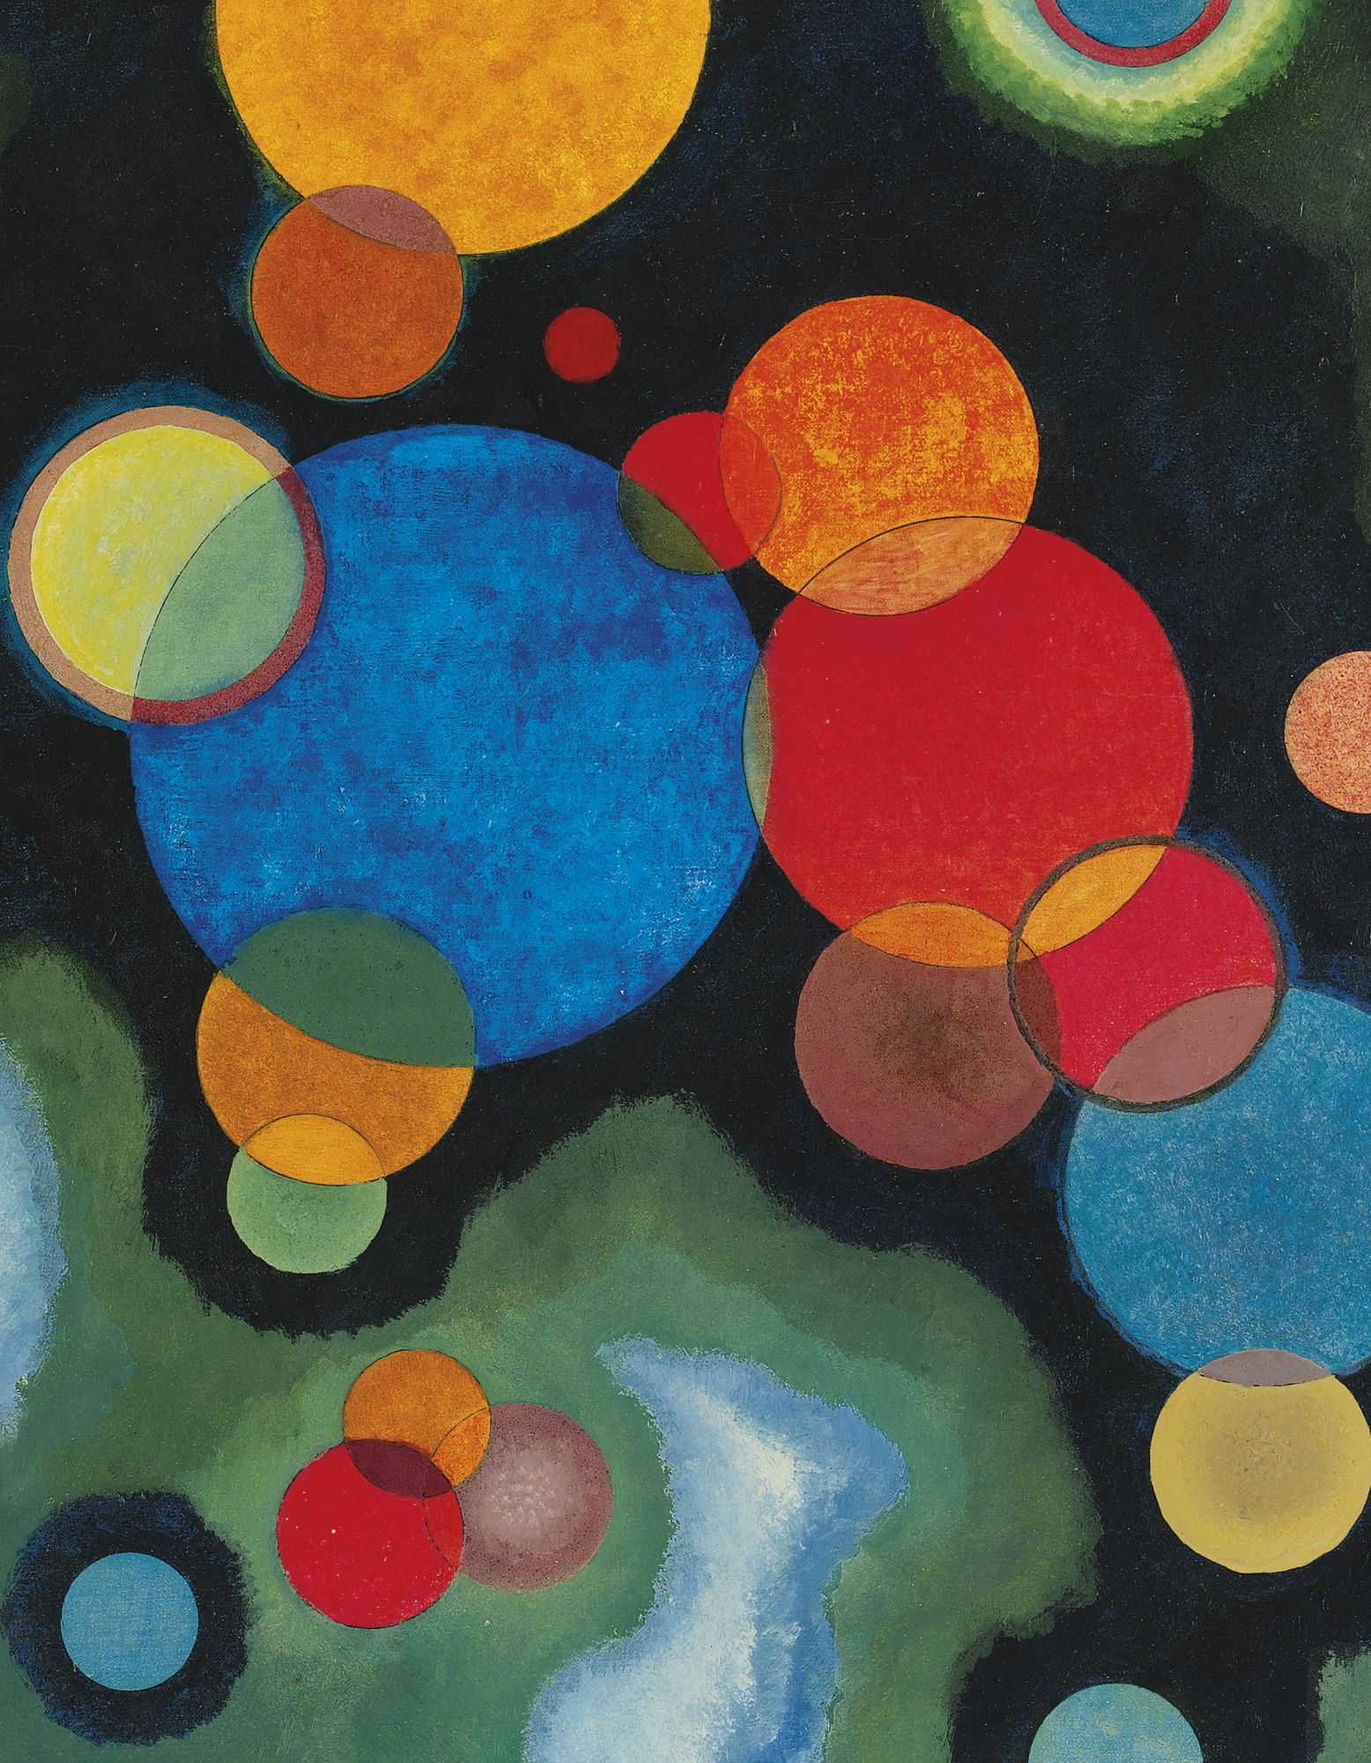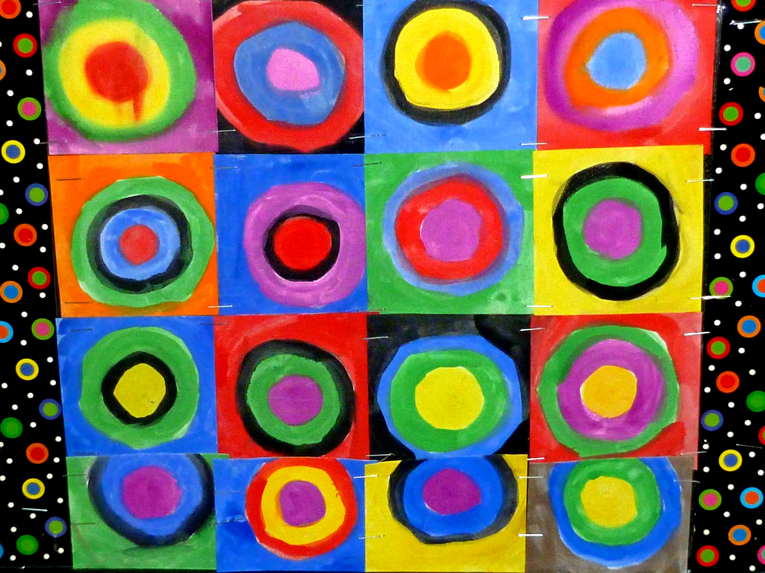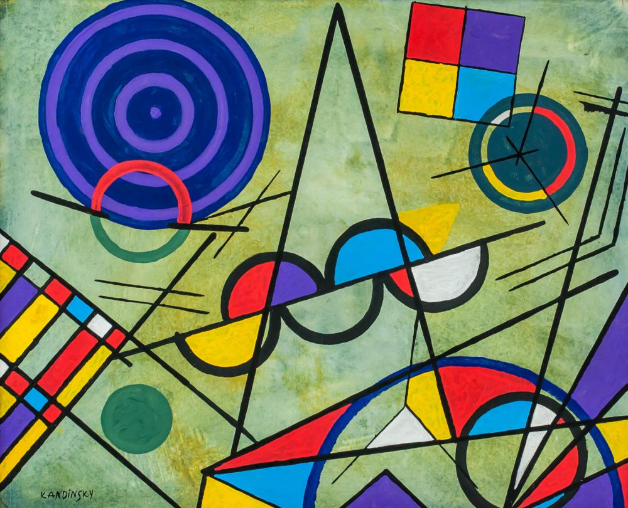

I can change brush sizes

To make it bigger, choose a bigger number. To make it smaller choose a smaller number



George Seurat Pointillism

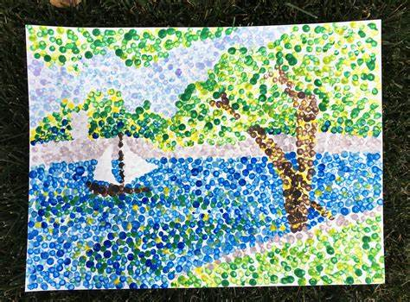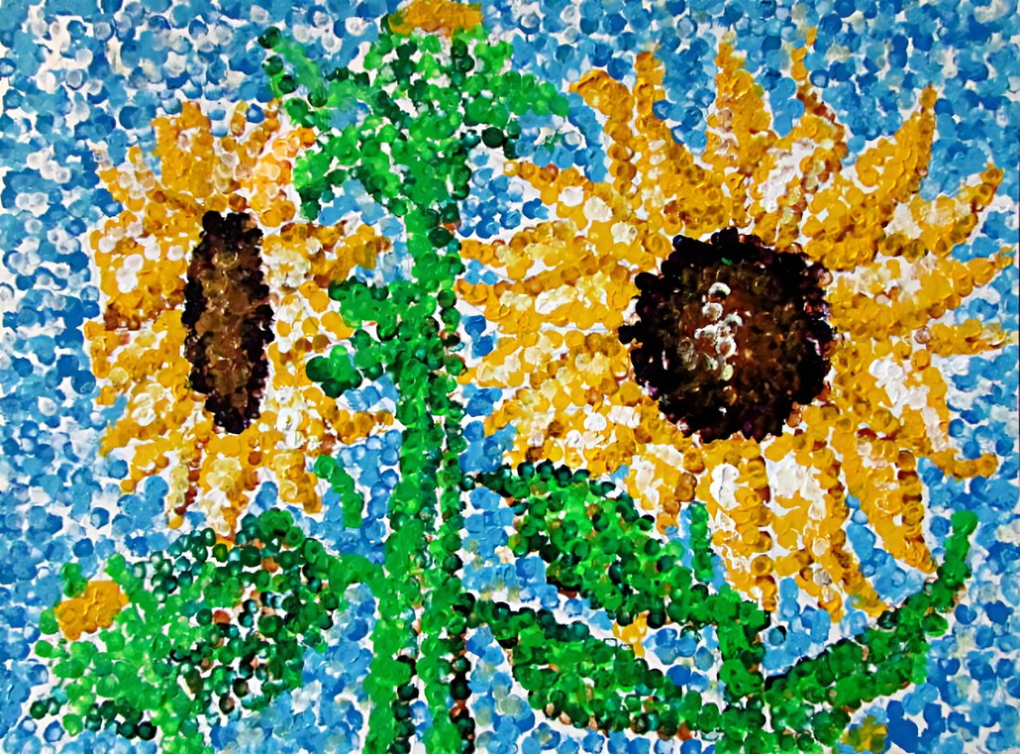

To use different colours



Henri Matisse

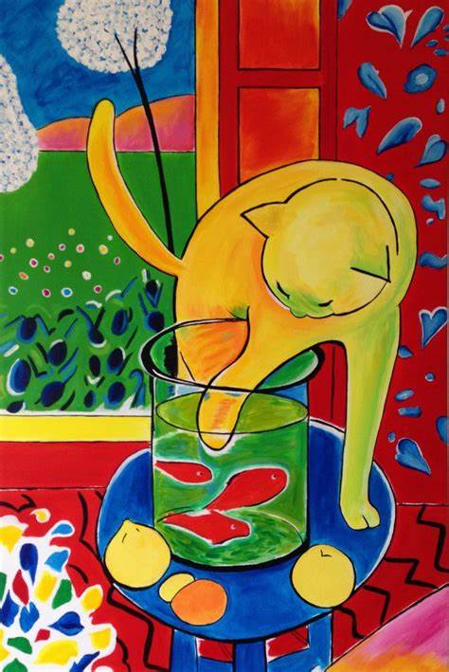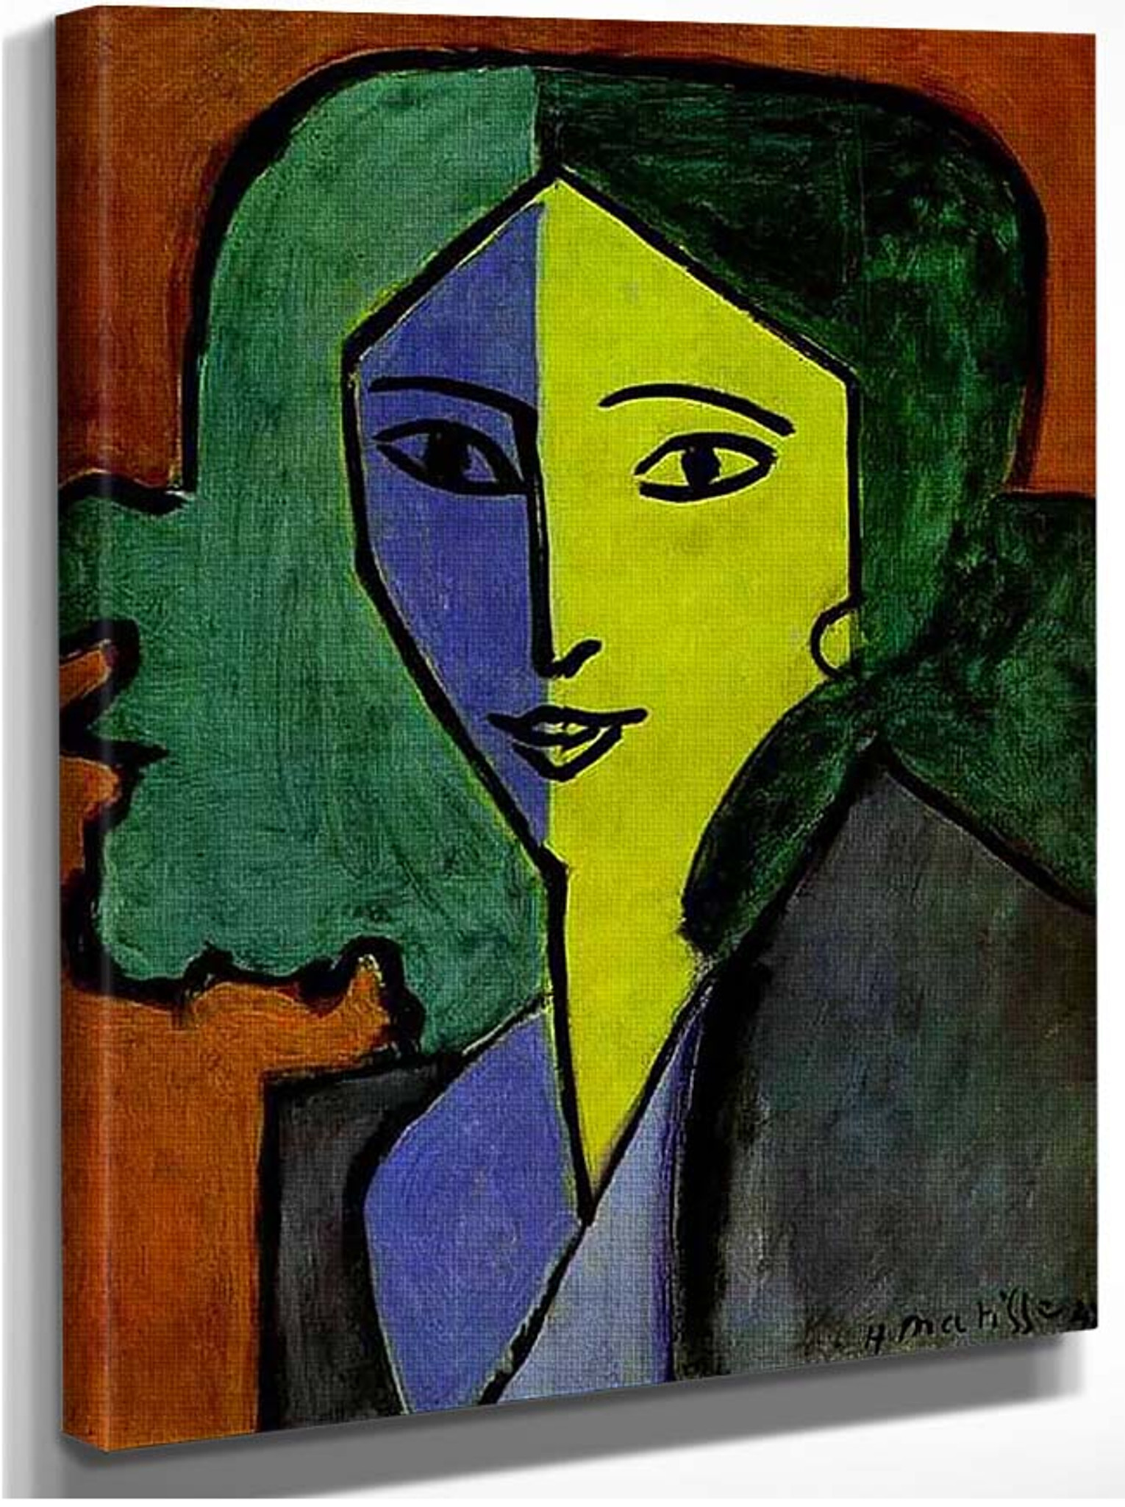

To use the shape and line tools

 Piet Mondrian

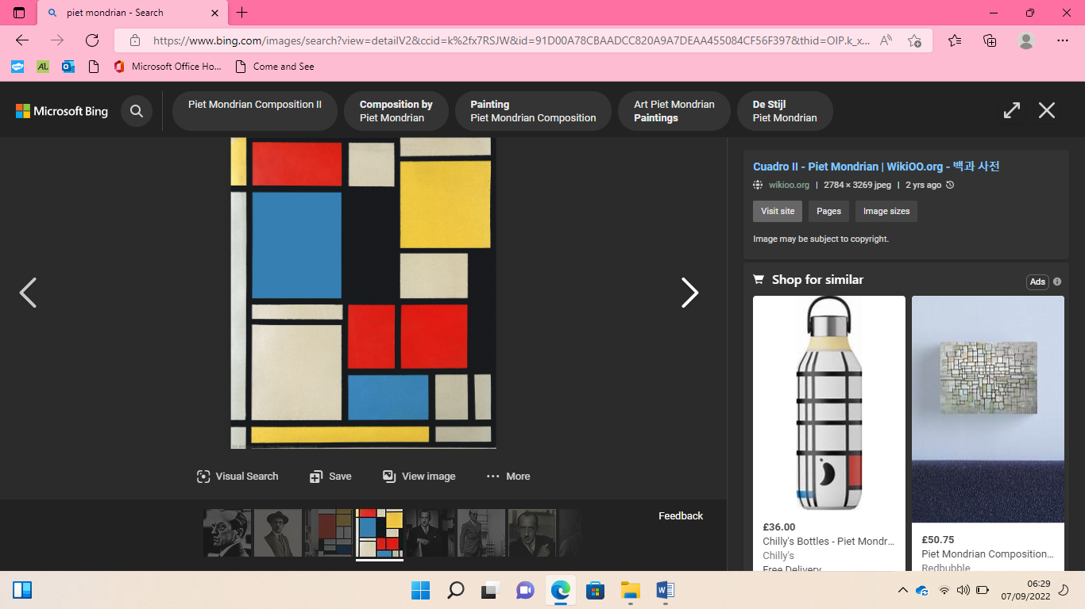

**Creating media – digital painting**