I will need…

I will need to…

My chair will look like...

I want it to look like this because…

Evaluating

I like… because…

It is like my plan… because…

Next time I would change… because…

|  |
| --- |
| Weaving |

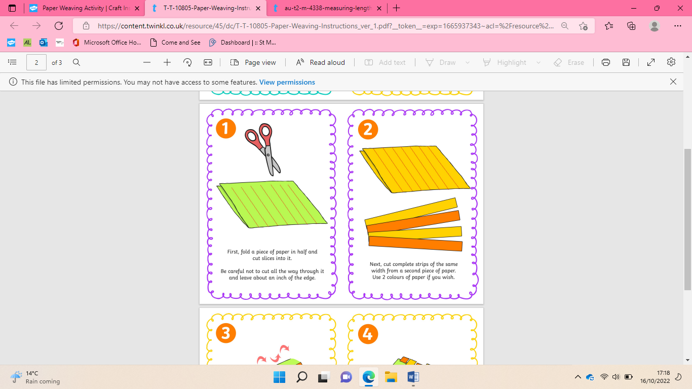

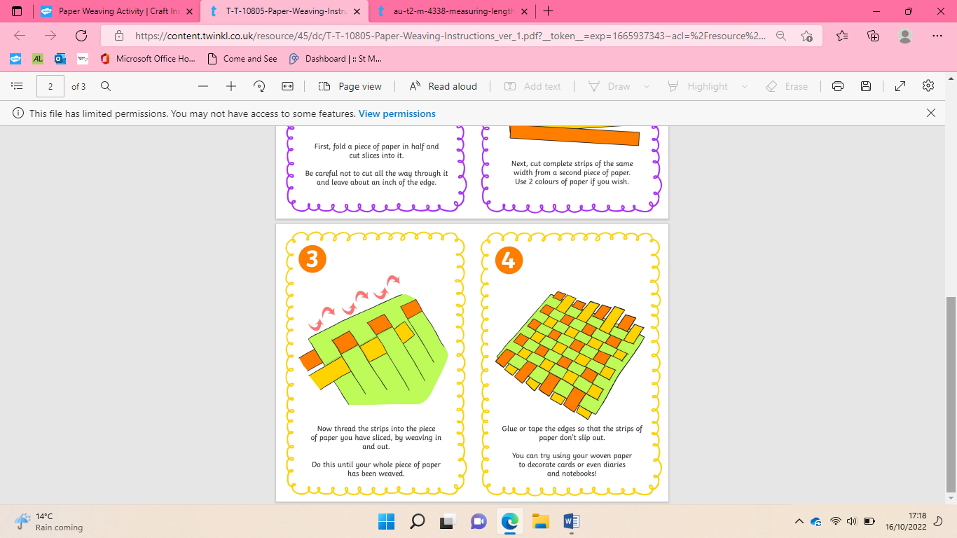

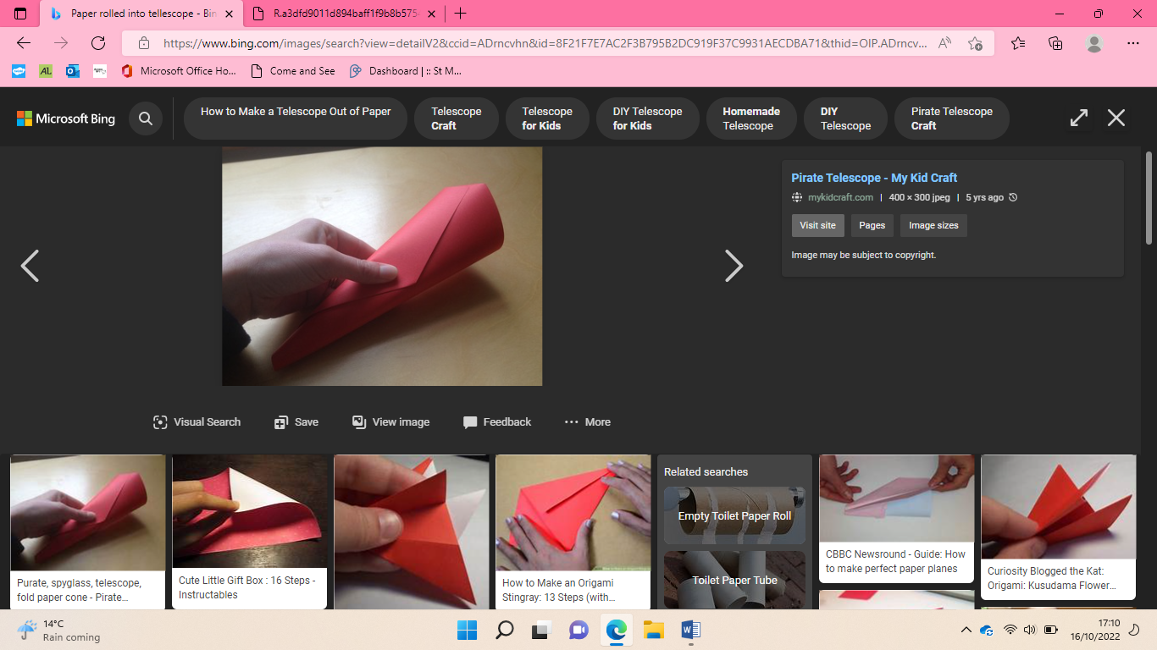Roll 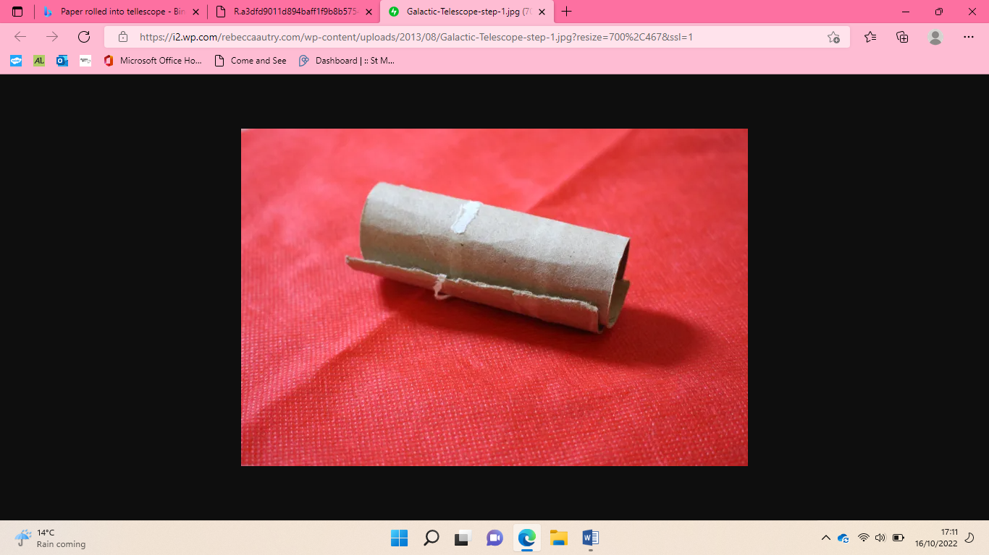

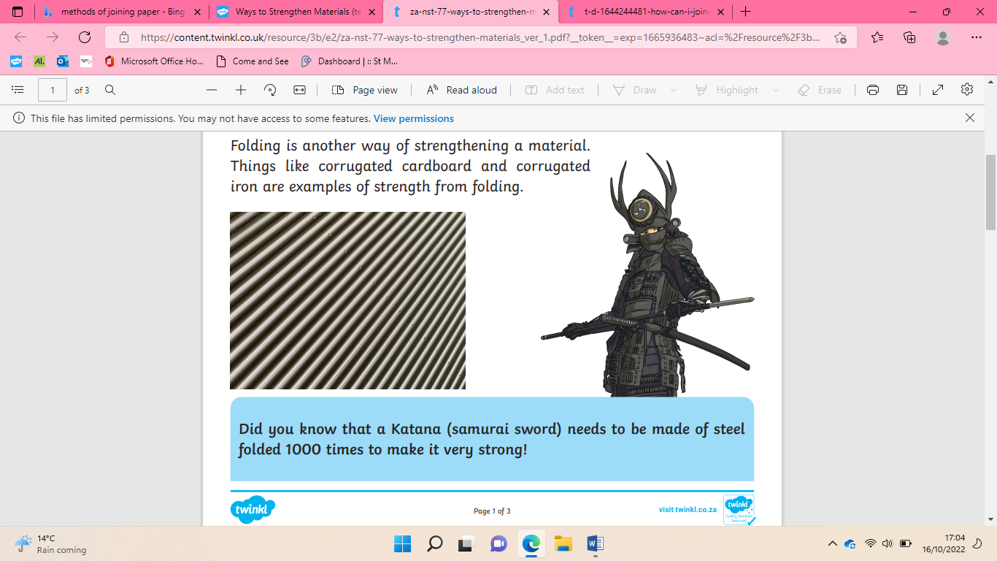Fold 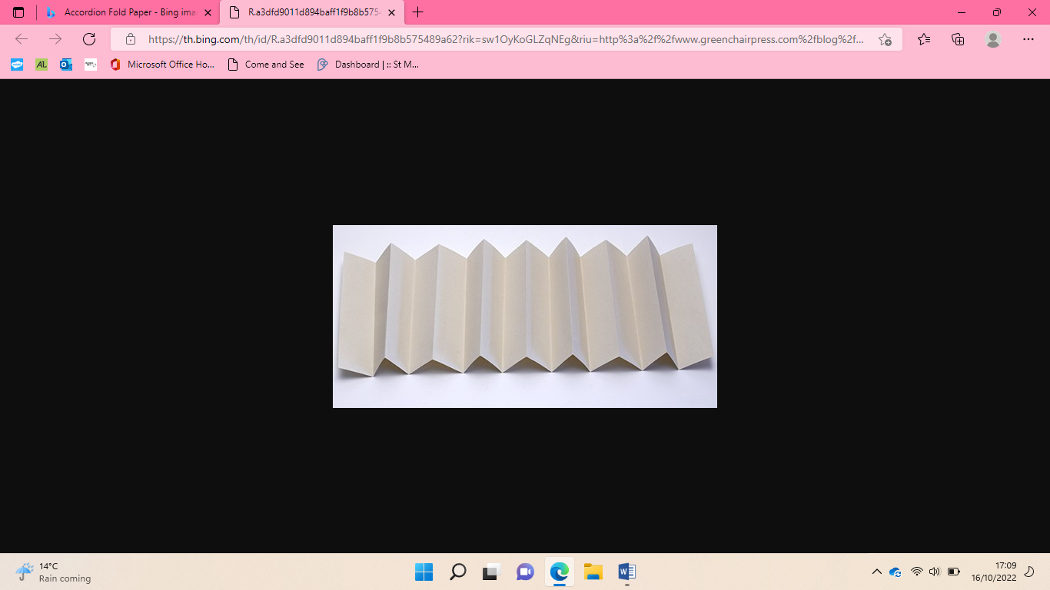

How to measure with a ruler?

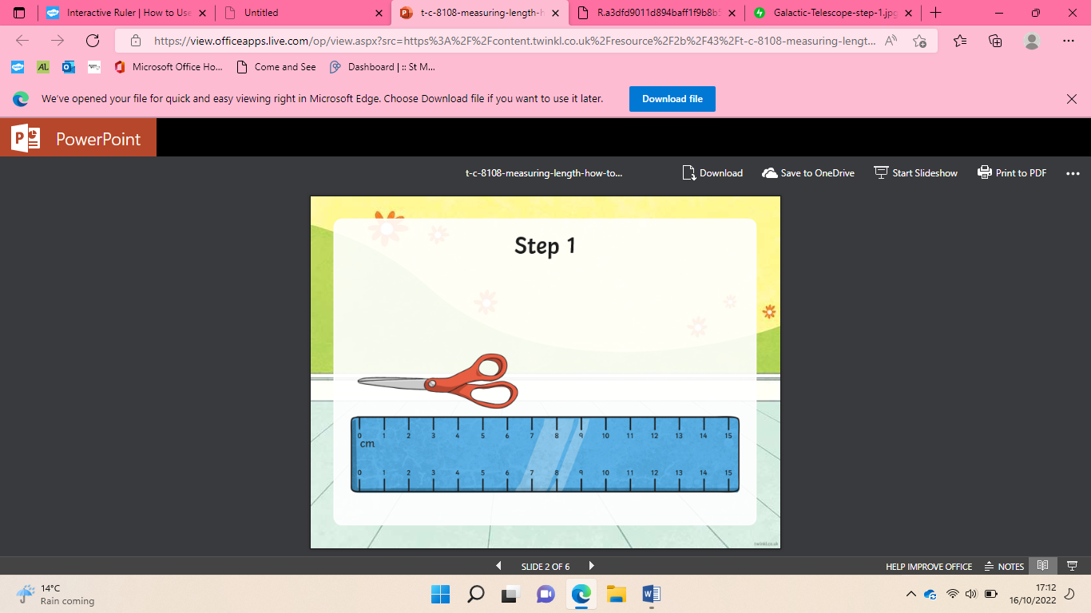

1. Make sure you start from 0
2. Check if you are measuring in cm or mm
3. Find where the end of your object is and that number is how long the object is.

If you want to draw a line a certain length.

1. Start from 0
2. Check if you are measuring in cm or mm
3. Move your pencil along the ruler until you get to the number that you want to stop at

|  |
| --- |
| Methods of joining |

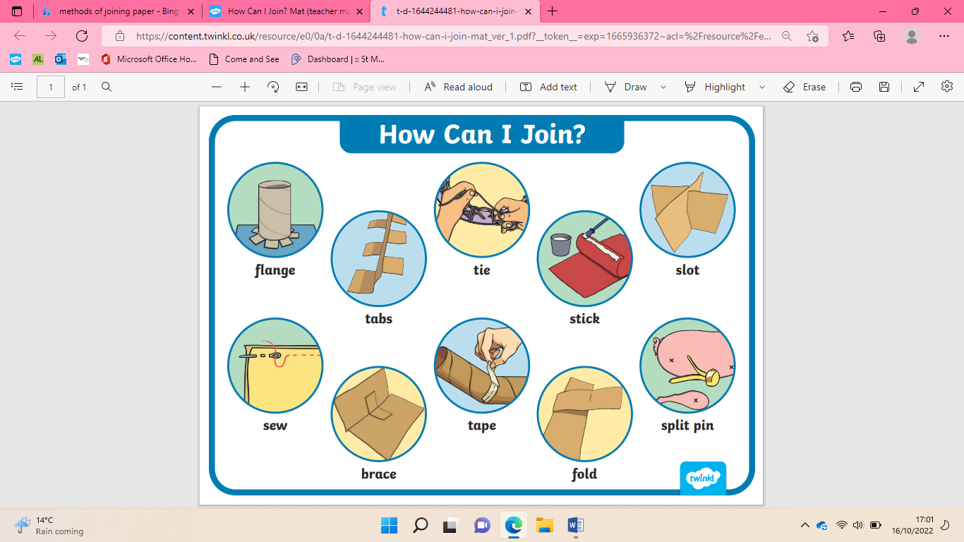

Planning

|  |  |
| --- | --- |
| **Key Vocabulary** | |
| Strengthening | To make something stronger. |
| Materials | What something is made from. |
| Roll | To shape something by rounding off some of its edges. |
| Join | To connect. |
| Measure | To find out the exact size. |
| Weave | To cross materials over one another. |
| Evaluate | To decide how good or bad something is. |

Strengthening materials

Make a chair for baby bear